**HIST 1331-001: Technology and Science in American Society to 1865**

**Spring 2024**

**T/Th 9:30-10:50**

**Instructor Information**

**Instructor:** Alexandra Rains

**Email:** [alexandra.rains@uta.edu](mailto:alexandra.rains@uta.edu)

**Instructor Office Hours:** T/Th12:30-1:30 in UH 318

**TA:** Candace Carlisle Vilas

**TA Email:** [cxc2840@mavs.uta.edu](mailto:cxc2840@mavs.uta.edu)

**TA Office Hours:**

**Course Description**

An introduction to the political, social, economic, and cultural history of the United States to 1865. This course is designed to help students who are pursuing degrees in nursing and the health professions understand and evaluate their society, comprehend the historical experience, and further develop reading and writing competencies and critical thinking skills.

**Course Objectives**

During this course, students will learn how to:

1. Identify key events, peoples, individuals, terms, periods, and chronology of the history of the United States; distinguish between historical fact and historical interpretation; and connect historical events in chronological chain(s) of cause and effect.

2. Develop critical thinking skills by discussing the living nature of history, using historical evidence to critique competing interpretations of the same historical events, explaining the nature of historical controversies.

3. Synthesize diverse historical information and evidence related to broad themes of U.S. history--including the history of public health and the medical professions--and present this information in coherent, well-articulated, and well-substantiated analytical discussions and other written assignments.

4. Develop the ability to connect choices, actions, and consequences to ethical decision making by examining the motivations and actions of key figures in U.S. history.

5. Develop an understanding of civic and social responsibility by examining interactions within and between regional, national, and global communities in U.S. history.

6. Demonstrate basic awareness of the historical geography of the United States.

**Course Expectations**

Expectations of Students

1. Check the course homepage, calendar, announcements, assignment page, and your email several times a week.
2. Keep up with your readings and assignments. They must be finished by the due date listed in the assignment description
3. Practice "Netiquette". Be polite and respectful in your postings (no "Flaming" or posting / sending negative, hurtful comments to others); use good grammar and correct spelling; don't write in all caps (it feels like you're shouting) or exotic fonts (they may not show up on everyone's computer). In short, present your best self!
4. Email your questions and concerns directly to your Instructor or TA (if one is assigned to the course), DO NOT use the Canvas inbox feature. I have had problems in the past with receiving messages sent through Canvas. I cannot guarantee a timely answer (or any response at all) if you do not send your questions via the posted email addresses outside of the Canvas system.

Expectations of Instructors

1. I will respond to general communications via email within 48-72 hours. Messages received during weekends and holidays may have a longer response window.
2. You will typically receive a grade for your assignments within a week of submission. I will notify you if I expect grading to take longer.

**Technology and Technology Requirements**

1. Access to a computer and stable Internet connection/browser are necessary to participate in discussions and assignments, access readings, transfer course work, and receive feedback.   
   View [What are the browser and computer requirements for Canvas? (Links to an external site.)](https://community.canvaslms.com/t5/Canvas-Basics-Guide/What-are-the-browser-and-computer-requirements-for-Canvas/ta-p/66)
2. Access to speakers and/or headphones for multi-media.   
   View the [UTA Library Technology page (Links to an external site.)](https://library.uta.edu/technology) for peripherals available for checkout.
3. Word processing software, such as Microsoft Office or Open Office. Microsoft Office is the standard office productivity software utilized by faculty, students, and staff. View download instructions below for obtaining. *YOU ARE ENTITLED TO USE OF THE MICROSOFT OFFICE SUITE AND ADOBE WITH YOUR NETID AND PASSWORD!*   
   View full list of [software supported by Office of Information Technology (OIT) (Links to an external site.)](https://oit.uta.edu/index.php#oit-services).
4. A PDF viewer, such as [Adobe Acrobat Reader DC (Links to an external site.)](https://get.adobe.com/reader/). *See the shouty message in #3.*
5. Any additional technology requirements will be announced on Canvas, or in class.

#### **Microsoft Office Download Instructions**

These directions are from the [OIT (Links to an external site.)](https://oit.uta.edu/). If you run into issues with the download please reach out to them for support.

* Before downloading, it is suggested to erase the installed version of Office (Word, PowerPoint, Excel, Access, & OneNote).  Once you have erased previous version/s, go to your student email via the UTA homepage or [Office 365 Mail (Links to an external site.)](https://mail.office365.com).
* Select your picture or initials at the top right of the screen.   
  You should be seeing the "My Account" tab
* Select My account
* Select "Install Status" (located on the left side of the screen)
* On the "Install Status" page select Install desktop applications.   
  You should be seeing a white screen that says "Office" and has numerous Office icons   
  At the bottom of the screen select the "Install" box.   
  A set up wizard will pop up.  It will have step by step instructions on how to finish downloading the software on your device.
* Your UTA email and password will be the password if it requires you to authenticate.

**Institution Information**

UTA students are encouraged to review the below institutional policies and

informational sections and reach out to the specific office with any questions. To view

this institutional information, please visit the Institutional Information page

(https://resources.uta.edu/provost/course-related-info/institutional-policies.php)

which includes the following policies among others:

• Drop Policy

• Disability Accommodations

• Title IX Policy

• Academic Integrity

• Student Feedback Survey

• Final Exam Schedule

**COVID-19 POLICY, SHOULD ONE BE NECESSARY FOR FALL 2023**

**Attendance Policy—This is Important!**

At The University of Texas at Arlington, taking attendance is not required but

attendance is a critical indicator of student success. Each faculty member is free to

develop his or her own methods of evaluating students’ academic performance, which

includes establishing course-specific policies on attendance.

*While UT Arlington does not require instructors to take attendance in their courses, the*

*U.S. Department of Education requires that the University have a mechanism in place to*

*mark when Federal Student Aid recipients “begin attendance in a course.”* UT

Arlington instructors will report when students begin attendance in a course as part of

the final grading process. Specifically, when assigning a student a grade of F, faculty

report must the last date a student attended their class based on evidence such as a test,

participation in a class project or presentation, or an engagement online via Canvas.

This date is reported to the Department of Education for federal financial aid recipients.

**Student Success Programs**

UT Arlington provides a variety of resources and programs designed to help students

develop academic skills, deal with personal situations, and better understand concepts

and information related to their courses. Resources include tutoring by appointment,

drop-in tutoring, e-tutoring, supplemental instruction, mentoring (time management,

study skills, etc.), success coaching, TRIO Student Support Services, and student success

workshops. For additional information, please email resources@uta.edu, or view the

Maverick Resources website.

The IDEAS Center (https://www.uta.edu/ideas/) (2nd Floor of Central Library) offers

FREE tutoring and mentoring to all students with a focus on transfer students,

sophomores, veterans and others undergoing a transition to UT Arlington. Students can

drop in or check the schedule of available peer tutors at www.uta.edu/IDEAS, or call

(817) 272-6593.

**Emergency Phone Numbers**

In case of an on-campus emergency, call the UT Arlington Police Department at 817-

272-3003 (non-campus phone), 2-3003 (campus phone). You may also dial 911. Non-emergency

number 817-272-3381

**Library Information**

Research or General Library Help

Ask for Help

• Academic Plaza Consultation Services (library.uta.edu/academic-plaza)

• Ask Us (ask.uta.edu/)

• Research Coaches (http://libguides.uta.edu/researchcoach)

Resources

• Library Tutorials (library.uta.edu/how-to)

• Subject and Course Research Guides (libguides.uta.edu)

• Librarians by Subject (library.uta.edu/subject-librarians)

• A to Z List of Library Databases (libguides.uta.edu/az.php)

• Course Reserves (<https://uta.summon.serialssolutions.com/#!/course_reserves>)

• Study Room Reservations (openroom.uta.edu/)

**GENERATIVE AI (CHATGPT AND OTHERS) POLICY**

Use of ChatGPT and other generative AI is allowed in *limited* circumstances that are not academically dishonest. Use of AI in your work must ALWAYS be noted in a submission note or footnote. Cases where use of AI may be appropriate are to help get started/over writer’s block, to improve on what you have already written, or to explain an idea you already have in simpler terms (or in a better way). This use of AI brings in the “human element” and YOU are the one using AI as a tool, it is not doing the work for you. It is academically dishonest to use AI to fully complete an assignment or to do research for you. And, without your human element, AI does not do good work. There will be more information and examples on how to use AI properly in the course module. But remember, if you use AI in an assignment, you must cite this use.

This is the suggested syllabus language from "the powers that be" - you will note it closely aligns with our course policy:

As a partner in your learning, it is important to both of us that any assignment submission is a pure reflection of your work and understanding.  The introduction of artificial intelligence options to complete academic work jeopardizes my ability to evaluate your understanding of our course content and robs you of the ability to master the subject matter.  Suspicions of use of artificial intelligence aids will be referred to the Office of Community Standards as alleged violations of cheating, defined as “Any act designed to give unfair advantage to a student or the attempt to commit such an act.” and/or Falsification, which includes “Falsifying research data, laboratory reports, other academic work offered for credit, or other work completed that satisfies an assignment or course requirements;”.

Here is an infographic from AI for Education that aligns with our course policy that may be easier for you to understand:

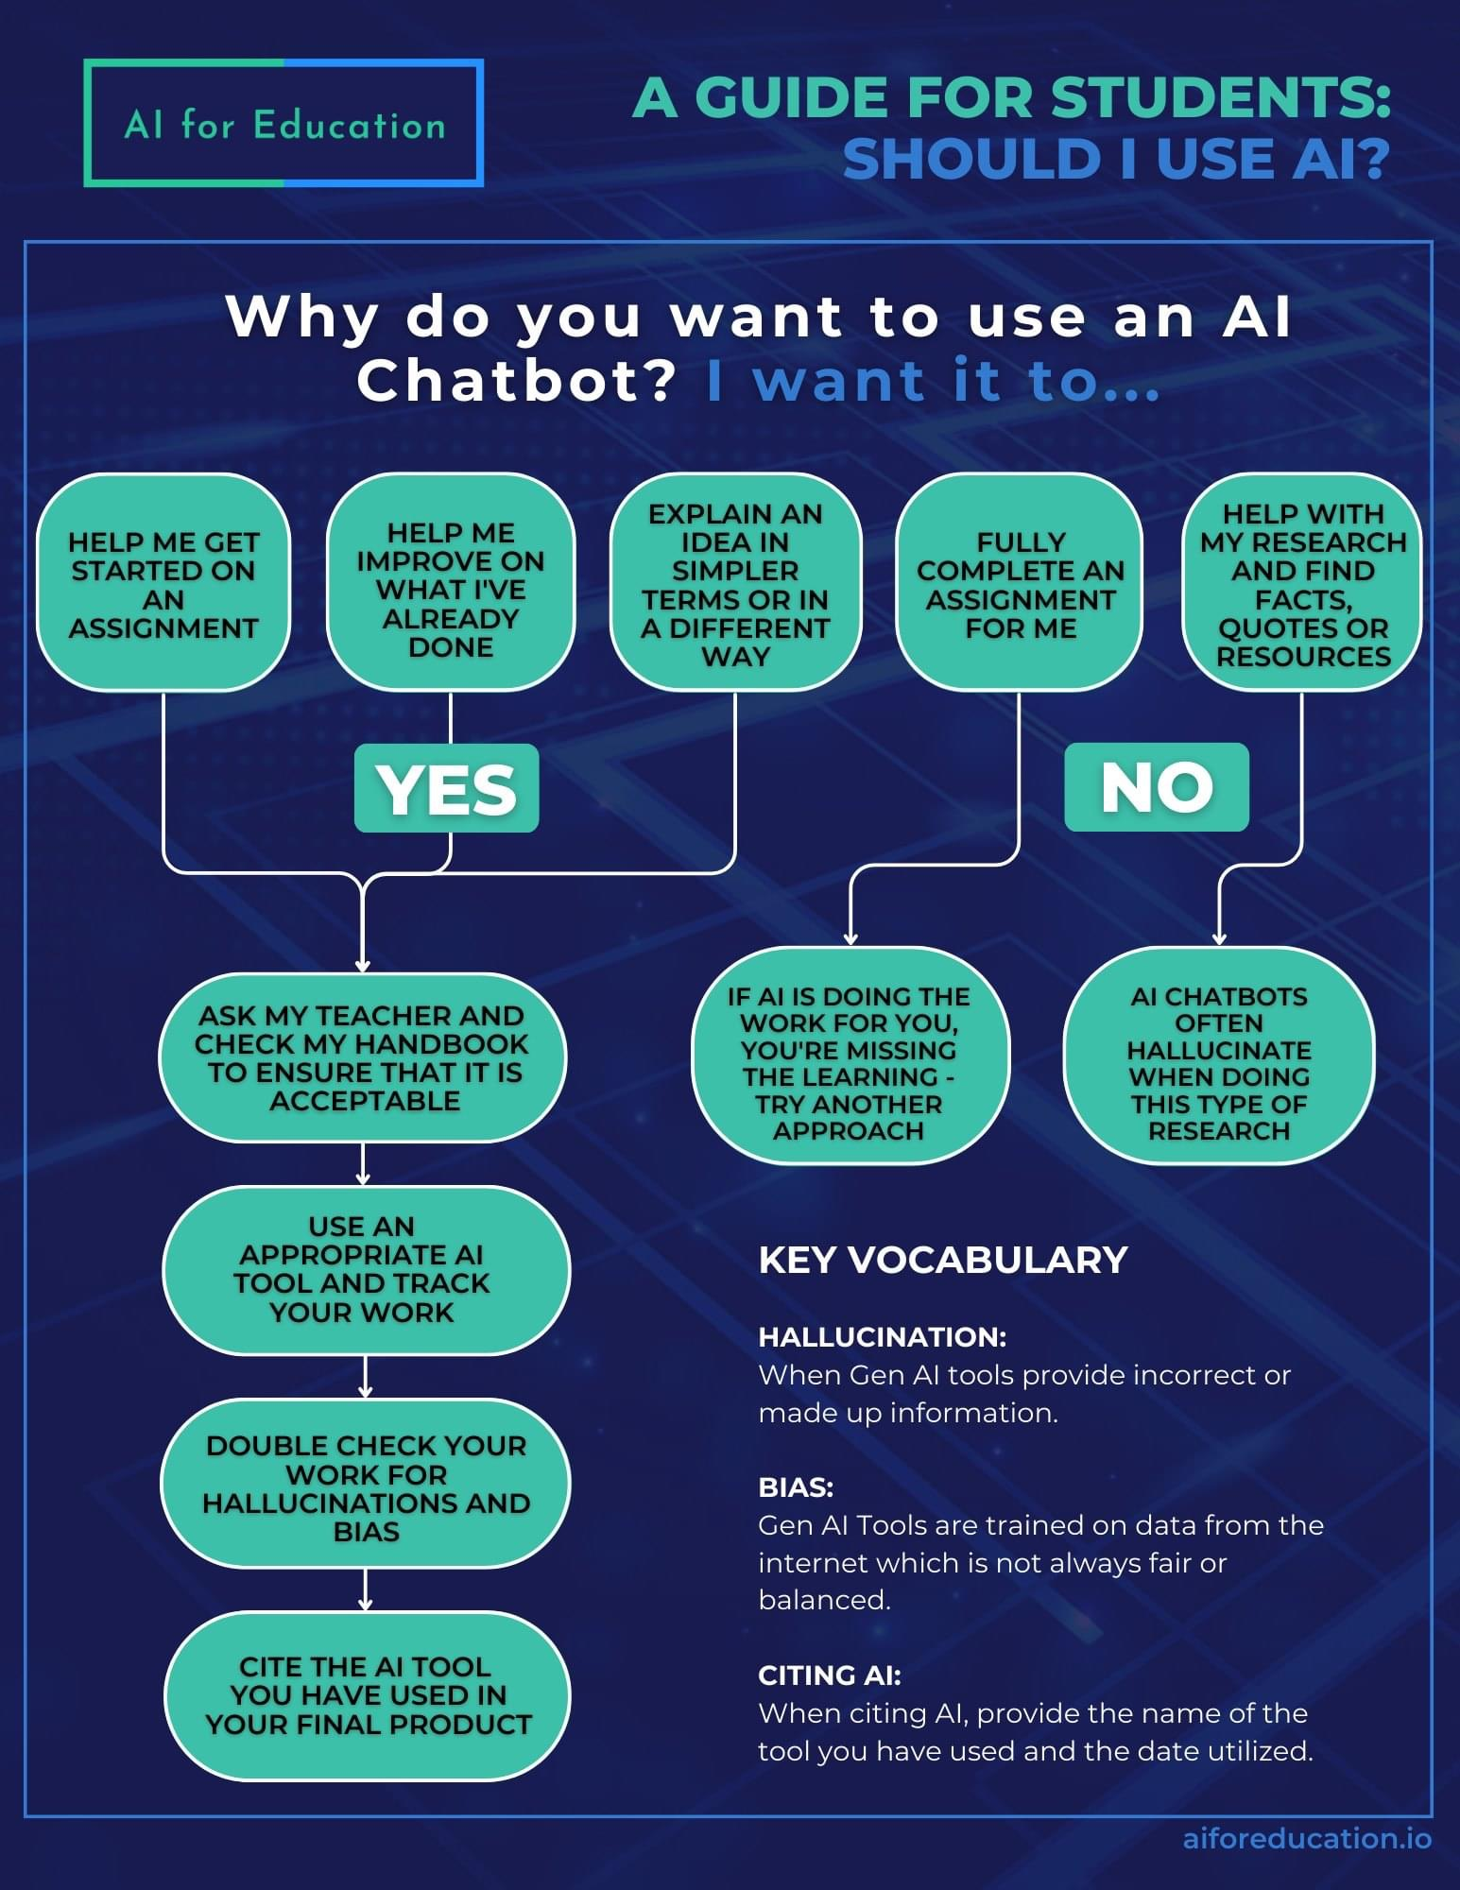

**Assignments and Grading**

**Attendance, 50 points**

You are adults, and as such, you are either learning how to navigate the adult world, or you are already old hands at it. With that in mind, I cannot force you attend class and realistically, you should be attending because you wish to further your education. However, things do happen—deadlines loom, people get sick, sometimes there is insane weather. Attend class, sign in, and you can earn a very comfortable pad to your grade just by doing what you should be doing anyway. I will explain the attendance policy more thoroughly in class. Attendance counts, is what I’m getting at.

**Untests, 100 points each**

There will be three (3) Untests throughout the course, and you will be able to work on the assignment throughout each module. This is an open resource/material/note assignment, so take the opportunity to really shine—use topics that you found especially interesting, or something that you have strong opinons about. An assignment information sheet will be made available in Canvas to describe Untest requirements in greater detail, and we will go over the assignment in class before the first Untest is due.

**Essay Topic Declaration, 25 points**

The final assignment for this course will be your Signature Essay, and we will be working toward its completion throughout the course. Not to worry--you will pick an essay topic from a list of approved subjects, so I do know that there will be sufficient materials for an essay!

**Research and Curation Worksheet, 50 points**

That’s right, you will be conducting some scholarly research as part of your course grade! This worksheet is going to get you started. We will go over it in greater detail in class, but check out the worksheet itself and the requirements in Canvas!

**Signature Essay, 100 points**

A signature essay of 2-3 pages (introduction, three [3] body paragraphs, and a conclusion) will be due at the end of Module 4. We will be building toward this essay throughout the course, and this is the final element in your writing development in HIST 1331.

**Rubrics**

As I am sure you have noticed, the class is quite large, and I believe in being as fair and equitable as possible across the board. Since that is the case, rubrics will be provided to you with each assignment, and they will be what guides my grading process. I will discuss this at greater length in class on the first day, and before the first Untest.

***All assignments must be submitted via Canvas if you wish to receive credit.***

Letter Grades

A………………….90-100

B………………….80-89

C………………….70-79

D………………….60-69

F………………….59 and below

**The 50 Percent Rule**: As long as you submit your assignments on time, you will not make lower than 50 percent. Even if your grade should (according to the rubric) be the equivalent of a 37, or a 15, or a 49, you will receive at least 50 percent credit for trying. So, even if it seems like you have completely bombed an assignment, do not fear—you can probably recover. Talk to me if you have questions, or concerns.

***You must submit something to qualify for the 50 Percent Rule, even if it is just a line that states, I want to use the 50 Percent Rule for this assignment.***

**Late Work**: I will accept late work, with the following penalties.

24 hours: 5% from the overall score earned.

48 hours: 20% from the overall score earned.

72 hours: 35% from the overall score earned.

96 hours: 50% from the overall score earned.

*Please note that the instructor reserves the right to make adjustments to this syllabus as deemed necessary. Students will be notified of changes via Announcements in Canvas. AR*

**Semester Schedule**

**Module One, Ancient America**

Week One, Syllabus and Ancient America 1/16

Native American Creation Stories

Week Two, European Expansion and Colonization 1/23

Thomas Morton on Native Americans

Week Three, England in North America 1/30

PDF, Readings from Nicolas Culpeper

PDF, Williams’ Anti-Smallpox Pamphlet

***Census Date 1/31***

**Module Two, Colonial Society in the 18th Century**

Week Four, Indigenous American Science and Tech 2/6

And the Origins of the French and Indian War

PDF, Medicine in Colonial North America

***Untest 1 due by 2/8 at 11:59 pm Arlington, TX time. 2/8***

Week Five, French and Indian War and Revolutionary America 2/13

Challenging Societal Norms

Week Six, American Revolution and A New Nation 2/20

PDF, Barras and Greub, Bioterrorism

***Essay Topic Declaration due by 2/22 at 11:59 pm Arlington, TX time. 2/22***

**Module Three, From the Articles of Confederation to the Constitution**

Week Seven, From Early Republic to the War of 1812 2/27

Mary Smith Cranch on Politics

PDF, Selections from Benjamin Rush’s Oration on Native American

Medicine

Week Eight, America in the 1830s and Modernists and Moralizers 3/5

PDF, George Washington and Cancer

***Untest 2 due by 3/7 at 11:59 pm 3/7***

**Week Nine: Spring Break** 3/11

No class!

Week Ten, The Cotton South and Westward Expansion 3/19

PDF, Biography of James Craik

***Research and Curation Worksheet due by 3/21 at 11:59 pm Arlington, TX time. 3/21***

**Module Four, Democracy in America**

Week Eleven, A Prelude to War and the Mexican-American War 3/26

The Act for the Relief of Sick and Disabled Seamen

***Last Day to Drop 3/29***

***Submit all requests to your advisor before 4:00 pm Arlington, TX time.***

Week Twelve, The California Goldrush, Westward Expansion, and Foreign Policy 4/2

<https://www.psychologytoday.com/us/blog/out-the-ooze/202008/snapshot-life-in-19th-century-insane-asylum>

***Untest 3 due by 4/4 at 11:59 pm Arlington, TX time. 4/4***

Week Thirteen, Wilmot Proviso, the Ostend Manifesto and the Brink 4/9

Folk Medicine in the Antebellum South

Chapter selection from Katherine Kemi Bankole-Medina’s

*Slavery and medicine : enslavement and medical practices in antebellum Louisiana*

Week Fourteen, The Civil War 4/16

Chapter selection from Tamara Venit Shelton’s *Herbs and Roots: A History of*

*Chinese Doctors in the American Medical Marketplace*

<https://www.ohs.org/events/herbs-and-roots-chinese-doctors-in-america.cfm>

Week Fifteen, The Civil War and Post-bellum Medicine 4/23

Civil War Health Providers

Dr. Mary Edwards Walker:

<https://cfmedicine.nlm.nih.gov/physicians/biography_325.html>

Dr. Alexander T. Augusta: <https://www.nlm.nih.gov/exhibition/bindingwounds/inuniform.html>

Nurses Susie King Taylor and Ann Stokes: <https://www.nlm.nih.gov/exhibition/bindingwounds/nursing.html>

Nurse Clara Barton (summary from Ken Burn documentary The Civil War): <https://www.pbs.org/kenburns/the-civil-war/clara-barton>

Week Sixteen, L ast Day of Spring Classes **4/30**

***Signature Essay due by 4/30 at 11:59 pm Arlington, TX time in Canvas***